One Day Webinar on “Disaster & Management Strategies”

Event Date: 13th October, 2021
Event Venue: Google Meet (https://meet.google.com/sio-orka-fnq)
Organizing unit / agency / collaborating agency: Department of Life Sciences & Allied Health Sciences, UIS
Number of participants: 15+4*
*Faculty and Students

Summary of Report: (objective, highlights and snapshots like images should be included)

The Department of Life Sciences and Allied Health Sciences in collaboration with ESM Cell, SBBSU under the aegis of IQAC organized a one-day webinar on “Disaster & Management Strategies” on 13th October 2021(3 pm onwards) through GOOGLE MEET. The Resource person for the event was Dr. Aksh Sharma, Coordinator of ESM Cell, SBBSU. The event was organized to celebrate International Day of Disaster Reduction.
The session was inaugurated by Dr. Shweta Singh, Coordinator of Life Sciences and Allied Health Sciences. On the commencement of the session, the expert started with introduction to disaster and different types of disasters. In her presentation, she highlighted basic concepts of disaster management, different phases of disaster management and explained many disasters related terminology with nice pictorial examples. The aim of this webinar was to sensitize the participants about disaster risk management and to understand the principles of disaster risk reduction and sustainable development. Advocating a “shift” in understanding disaster management, she said community-based approaches, increasing awareness, use of appropriate technologies and indigenous methods could go a long way in mainstreaming disaster management. Then she emphasized about disaster mitigation cycle, National Disaster management structure and Risk formula.
Faculty, research scholars and students from different departments joined the webinar in virtual mode. E- certificates were given to the participants (Annexure -I). The session came to an end with vote of thanks by the Coordinator of Life Sciences.

Glimpses of the Webinar:
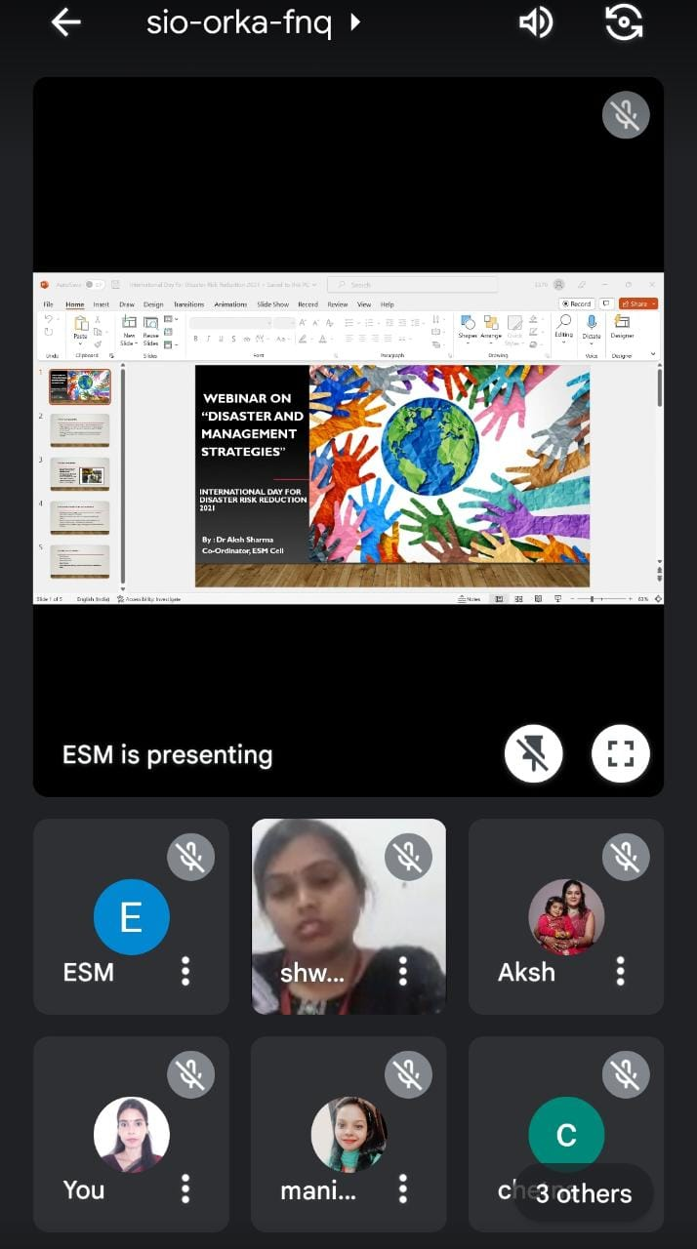

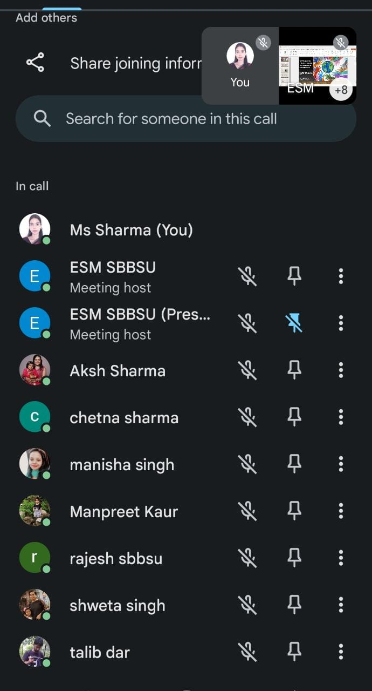
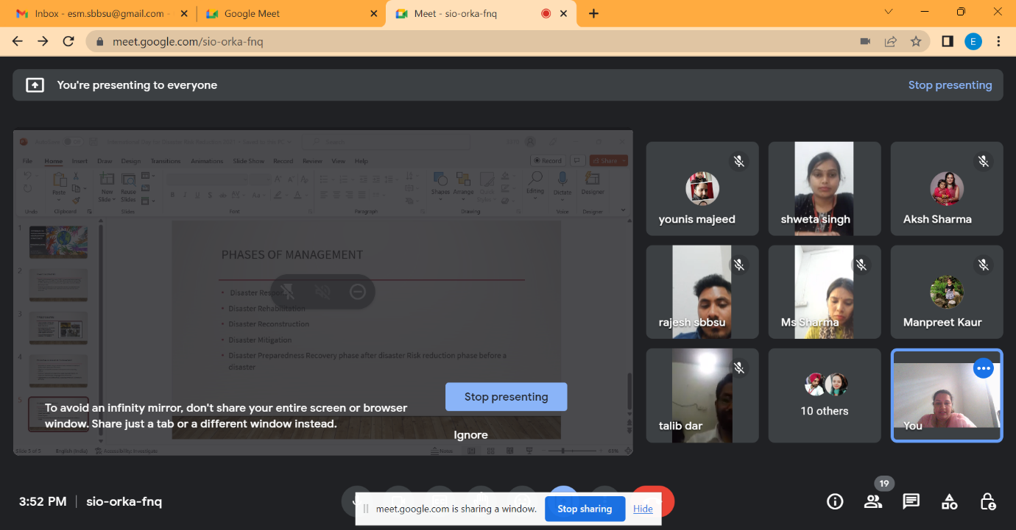

Coordinator Member
(Life Sciences & Allied Health Sciences) (ESM Cell)

